The Choice
BY DOROTHY PARKER
He'd have given me rolling lands,
Houses of marble, and billowing farms,
Pearls, to trickle between my hands,
Smoldering rubies, to circle my arms.
You- you'd only a lilting song,
Only a melody, happy and high,
You were sudden and swift and strong-
Never a thought for another had I.
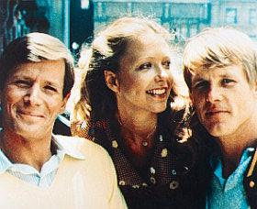
He'd have given me laces rare,
Dresses that glimmered with frosty sheen,
Shining ribbons to wrap my hair,
Horses to draw me, as fine as a queen.
You- you'd only to whistle low,
Gayly I followed wherever you led.
I took you, and I let him go-
Somebody ought to examine my head!

