A short story
By Judith Gorog

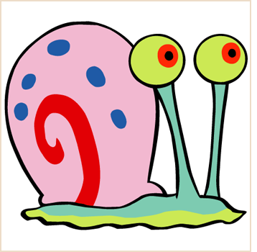
No one ever said that Melinda Alice was nice. That wasn’t the word used. No, she was clever, even witty. She was called—never to her face, however—Melinda Malice. Melinda Alice was clever and cruel. Her mother, when she thought about it at all, hoped Melinda would grow out of it. To her father, Melinda’s very good grades mattered.
It was Melinda Alice, back in the eighth grade, who had labeled the shy, myopic new girl “Contamination” and was the first to pretend that anything or anyone touched by the new girl had to be cleaned, inoculated, or avoided. High school had merely given Melinda Alice greater scope for her talents.
The surprising thing about Melinda Alice was her power. No one trusted her, but no one avoided her either. She was always included, always in the middle. If you had seen her, pretty and witty, in the center of a group of students walking past your house, you’d have thought, “There goes a natural leader.”
Melinda Alice had left for school early. She wanted to study alone in a quiet spot because there was going to be a big math test, and Melinda Alice was not prepared. That ‘A’ mattered, so Melinda Alice walked to school alone, planning her studies. She didn’t usually notice nature much, so she nearly stepped on a beautiful snail that was making its way across the sidewalk.
“Ugh. Yucky thing,” thought Melinda Alice. Not wanting to step on the snail accidentally was one thing, but now she lifted her shoe to crush it.
“Please don’t,” said the snail.
“Why not?” retorted Melinda Alice.
“I’ll give you three wishes,” replied the snail evenly.
“Agreed,” said Melinda Alice. “My first wish is that my next,” she paused a split second, “my next thousand wishes come true.” She smiled triumphantly and opened her bag to take out a small notebook and pencil to keep track.
Melinda Alice was sure she heard the snail say, “What a clever girl,” as it made it to the safety of an ivy bed beside the sidewalk.
During the rest of the walk to school, Melinda was occupied with wonderful ideas. She would have beautiful clothes. “Wish number two, that I will always be perfectly dressed,” and she was just that. True, her new outfit was not a lot different from the one she had worn leaving the house, but that only meant Melinda Alice liked her own taste.
After thinking awhile, she wrote, “Wish number three. I wish for pierced ears and small gold earrings.” Her father had not allowed Melinda to have pierced ears, but now she had them anyway. She felt her new earrings and shook her beautiful hair in delight. “I can have anything: stereo, tapes, TV, videodisk, moped, car, anything! All my life!” She hugged her books to herself in delight.
By the time she reached school, Melinda was almost an altruist. She could wish for peace. Then she wondered, “Is the snail that powerful?” She felt her ears, looked at her perfect blouse, skirt, jacket, shoes. “I could make ugly people beautiful, cure cripples…” She stopped. The wave of altruism had washed past. “I could pay people back who deserve it!” Melinda Alice looked at the school, at all the kids. She had an enormous sense of power. “They all have to do what I want now.” She walked down the crowded halls to her locker. Melinda Alice could be sweet. She could be witty. She could—The bell rang for homeroom. Melinda Alice stashed her books, slammed the locker shut, and just made it to her seat.
“Hey, Melinda Alice,” whispered Fred. “You know that big math test next period?”
“Oh, no” grimaced Melinda Alice. Her thoughts raced; “That snail made me late, and I forgot to study.”
“I’ll blow it,” she groaned aloud. “I wish I were dead.”
Myopic: nearsighted, needing glasses
Altruist: a person concerned about
others

